Great Stellated Dodecahedron

Definition
# Source: AI Source: Provided by: [Data Path: Persons Table -> ID Column: 1, Name_En Column: Motasem Essam] -> From: [ChatGPT] on [7/25/2026]
The Great Stellated Dodecahedron is a regular non-convex polyhedron belonging to the four classical Kepler–Poinsot Polyhedra. It consists of 12 intersecting regular pentagrammic faces arranged symmetrically around a common center.
It is formed by extending the faces of a regular dodecahedron outward until they intersect to create five-pointed star-shaped faces.
Its Schläfli symbol is:
$$\boxed{\{\frac{5}{2},3\}}$$
Where:
- $5/2$ represents the regular pentagrammic face.
- $3$ indicates that three pentagrammic faces meet at each vertex.
It is called great because its stellated points extend farther outward than those of the Small Stellated Dodecahedron.
The Great Stellated Dodecahedron is also the dual of the Great Icosahedron.

Geometric Representation
# Source: AI Source: Provided by: [Data Path: Persons Table -> ID Column: 1, Name_En Column: Motasem Essam] -> From: [ChatGPT] on [7/25/2026]
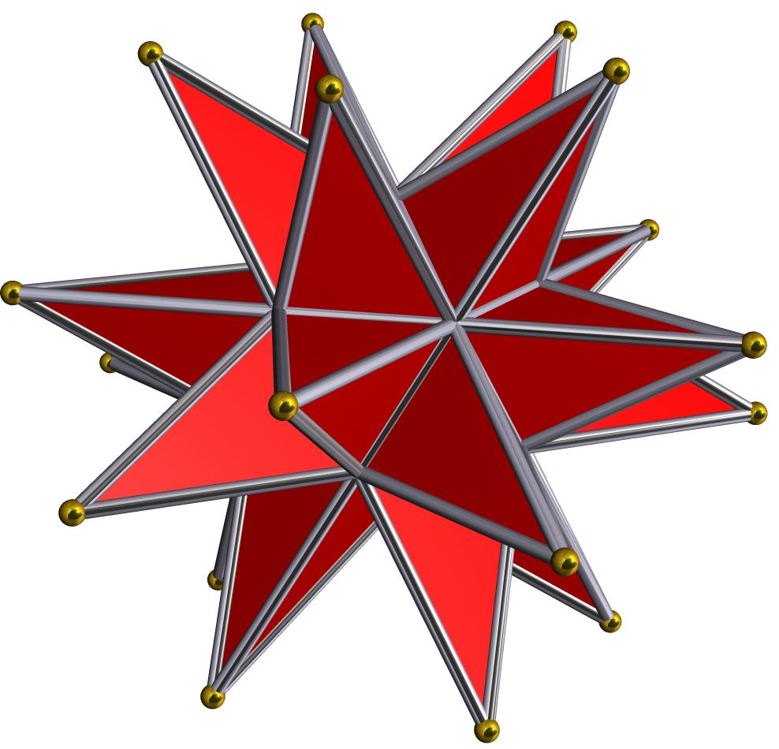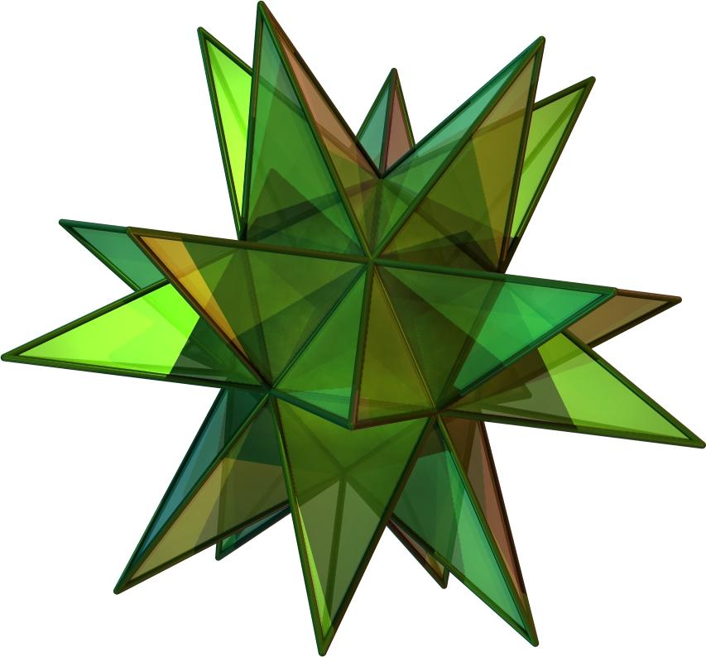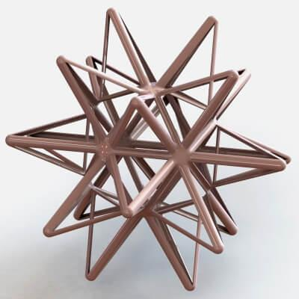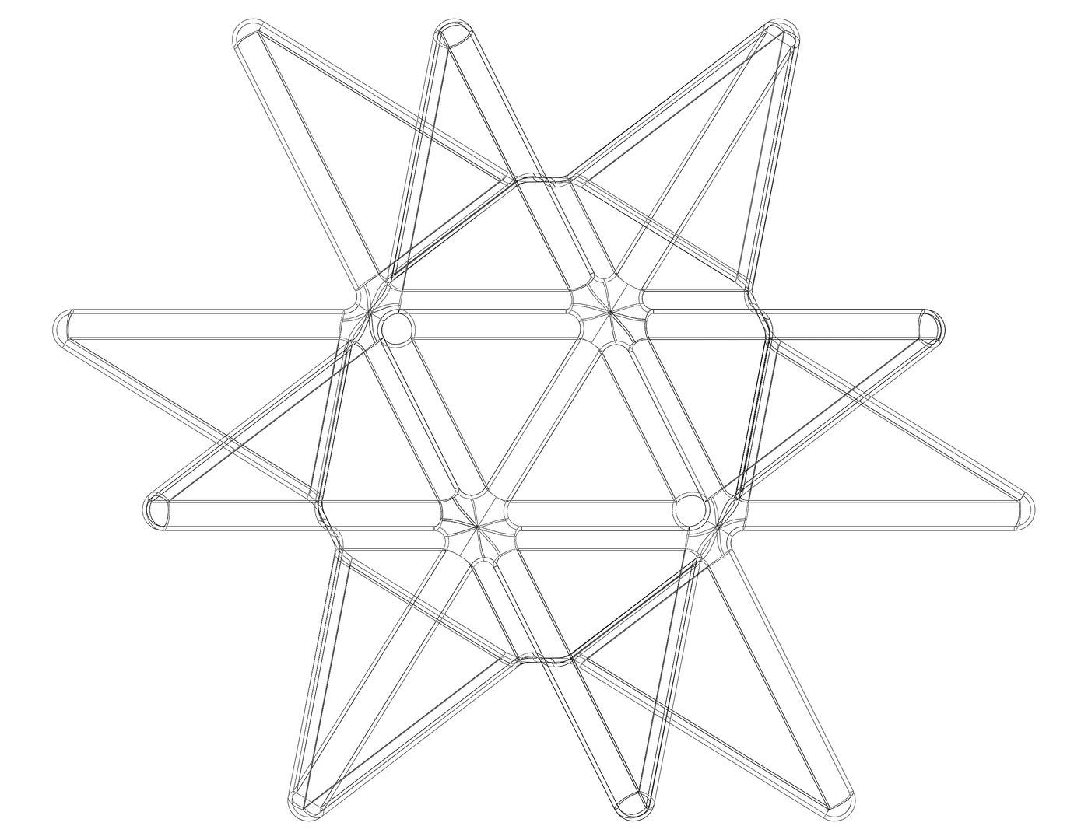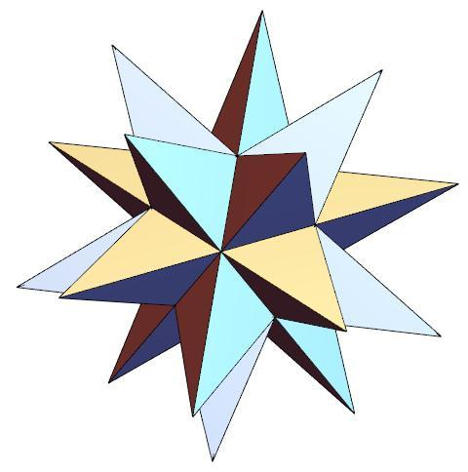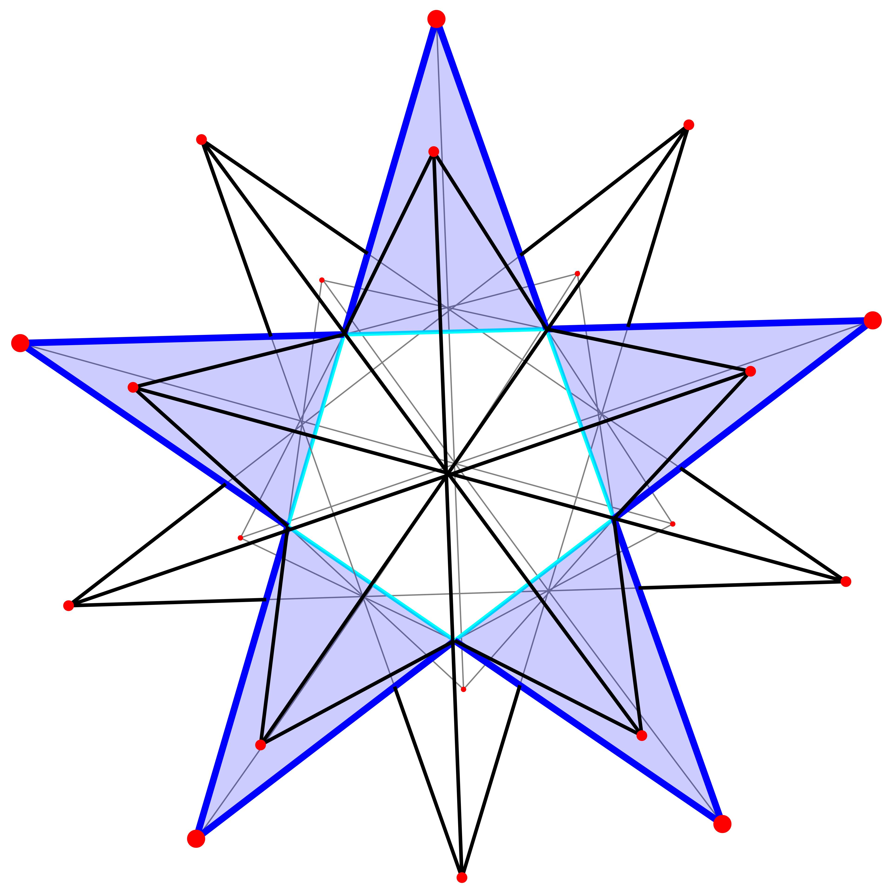

Geometric Structure
# Source: AI Source: Provided by: [Data Path: Persons Table -> ID Column: 1, Name_En Column: Motasem Essam] -> From: [ChatGPT] on [7/25/2026]
The Great Stellated Dodecahedron has a star-like structure consisting of 12 intersecting pentagrammic faces.
Its structure includes:
- Pentagrammic Faces: Twelve regular five-pointed star polygons.
- Edges: Thirty edges forming the boundaries of the pentagrammic faces.
- Vertices: Twenty outer vertices where three pentagrammic faces meet.
- Stellated Points: Sharp outward-pointing tips formed by the extended pentagonal geometry.
- Intersecting Faces: The pentagrammic faces pass through one another in space.
- Central Region: The extended star-shaped faces surround and intersect through the central region.
- Symmetrical Arrangement: Its faces and vertices are arranged with full icosahedral symmetry.

Mathematical Properties
# Source: AI Source: Provided by: [Data Path: Persons Table -> ID Column: 1, Name_En Column: Motasem Essam] -> From: [ChatGPT] on [7/25/2026]
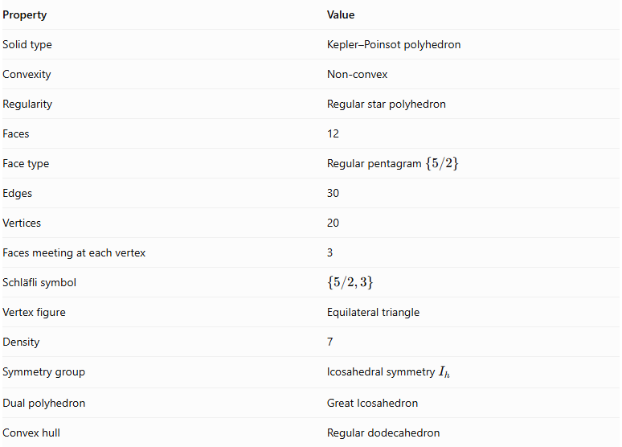
Property | Value
Solid type | Kepler–Poinsot polyhedron
Convexity | Non-convex
Regularity | Regular star polyhedron
Faces | 12
Face type | Regular pentagram $\{5/2\}$
Edges | 30
Vertices | 20
Faces meeting at each vertex | 3
Schläfli symbol | $$\{5/2,3\}$$
Vertex figure | Equilateral triangle
Density | 7
Symmetry group | Icosahedral symmetry $I_{h}$
Dual polyhedron | Great Icosahedron
Convex hull | Regular dodecahedron

Face Composition
# Source: AI Source: Provided by: [Data Path: Persons Table -> ID Column: 1, Name_En Column: Motasem Essam] -> From: [ChatGPT] on [7/25/2026]
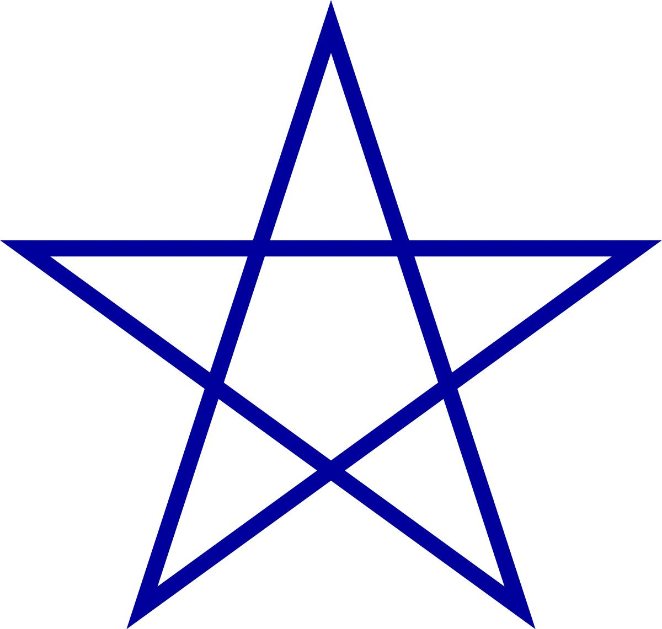
The Great Stellated Dodecahedron consists entirely of regular pentagrammic faces.
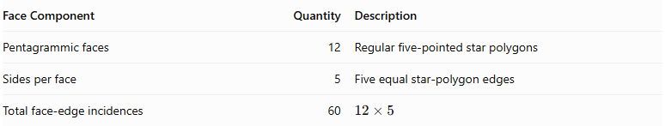
Face Component | Quantity | Description
Pentagrammic faces | 12 | Regular five-pointed star polygons
Sides per face | 5 | Five equal star-polygon edges
Total face-edge incidences | 60 | $$12×5$$
Important: Each pentagram is counted as one polyhedral face, not as five separate triangular faces, under the conventional Kepler–Poinsot counting system.
The pentagram is represented by:
$$\boxed{\{\frac{5}{2}\}}$$
The number 5 indicates five vertices, while 2 indicates the step used to connect the vertices.

Vertex Configuration
# Source: AI Source: Provided by: [Data Path: Persons Table -> ID Column: 1, Name_En Column: Motasem Essam] -> From: [ChatGPT] on [7/25/2026]
Three pentagrammic faces meet at each vertex.
The vertex configuration is:
$$\boxed{(\frac{5}{2},\frac{5}{2},\frac{5}{2})}$$
Or, more compactly:
$$\boxed{(\frac{5}{2})^{3}}$$
This indicates that three regular pentagrams meet at every vertex.
The Great Stellated Dodecahedron has the same 20 vertex positions as a regular dodecahedron, but its faces connect those vertices differently.

Construction
# Source: AI Source: Provided by: [Data Path: Persons Table -> ID Column: 1, Name_En Column: Motasem Essam] -> From: [ChatGPT] on [7/25/2026]
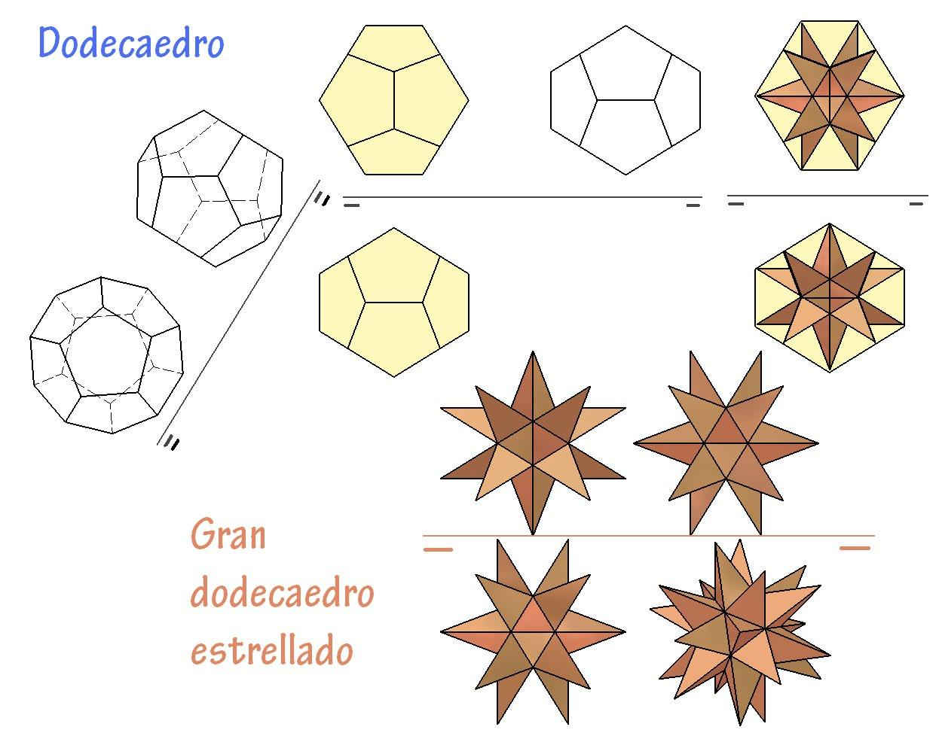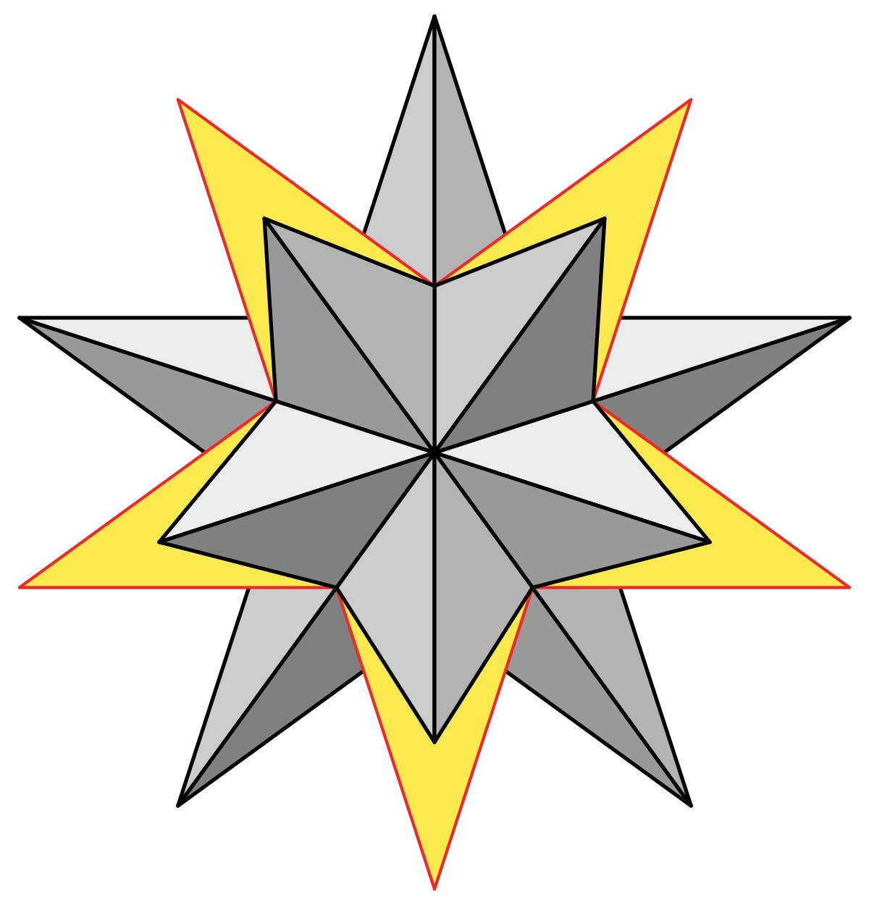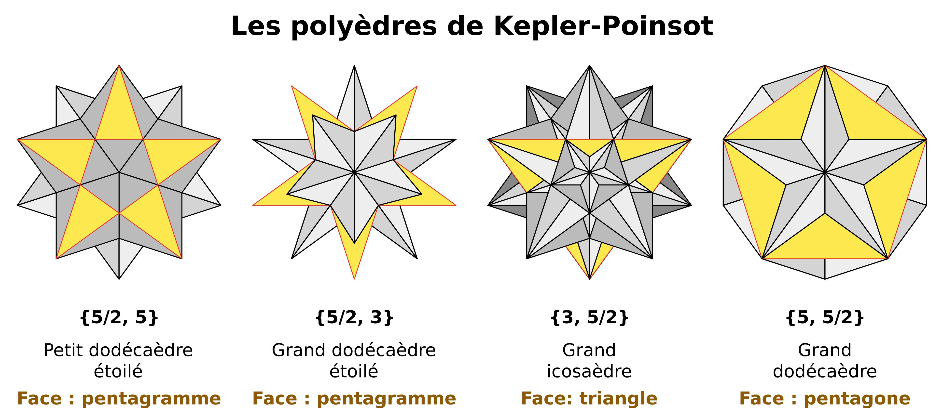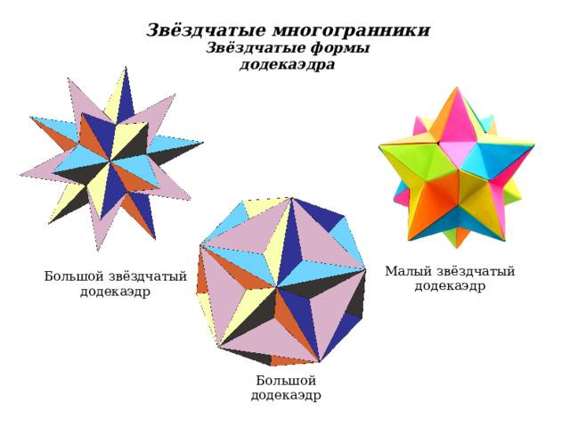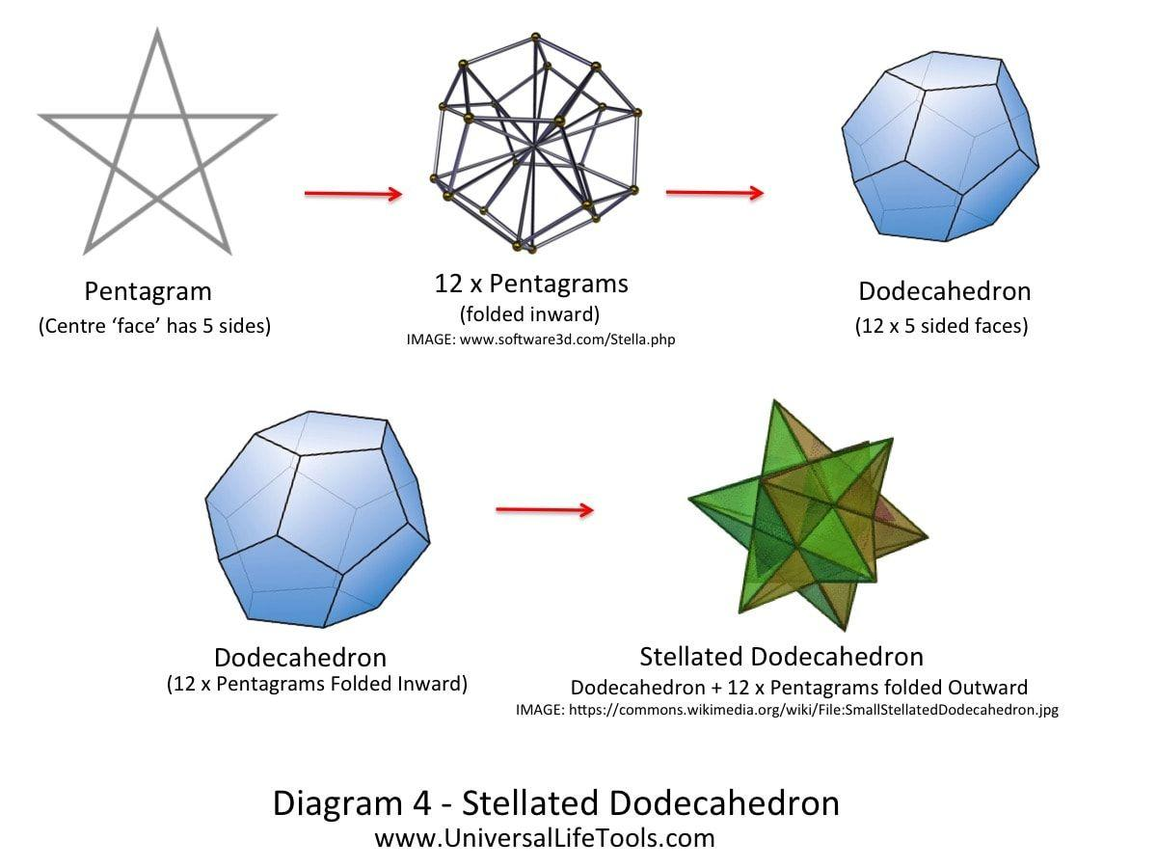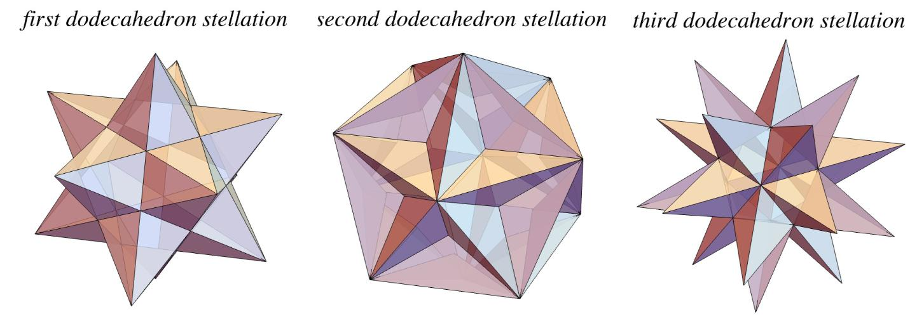
The Great Stellated Dodecahedron can be constructed by stellating a regular dodecahedron.
Construction steps:
- Begin with a regular dodecahedron containing 12 regular pentagonal faces.
- Extend the edges of the pentagonal faces beyond their original boundaries.
- Continue the extensions until the appropriate intersections create regular pentagrams.
- Arrange the 12 pentagrammic faces according to the symmetry of the original dodecahedron.
- Extend the star-shaped geometry to its complete stellated form.
- Preserve the intersecting face arrangement to obtain the Great Stellated Dodecahedron.
Another construction method is to attach 20 triangular pyramids to the faces of a regular icosahedron. The pyramid dimensions are chosen so that their triangular sides lie in the appropriate pentagrammic planes.

Geometric Dimensions and Formulas
# Source: AI Source: Provided by: [Data Path: Persons Table -> ID Column: 1, Name_En Column: Motasem Essam] -> From: [ChatGPT] on [7/25/2026]
Let $a$ represent the edge length of each regular pentagrammic face.

Regular Pentagram Geometry
# Source: AI Source: Provided by: [Data Path: Persons Table -> ID Column: 1, Name_En Column: Motasem Essam] -> From: [ChatGPT] on [7/25/2026]
The pentagram is constructed from five equally spaced vertices on a circle, connected by skipping one vertex each time.
Its star-polygon notation is:
$$\{\frac{5}{2}\}$$
The golden ratio is an important component of its geometry:
$$φ=\frac{1+\sqrt{5}}{2}$$
The diagonal-to-side ratio of a regular pentagram is:
$$\boxed{φ=\frac{1+\sqrt{5}}{2}}$$

Surface Area
# Source: AI Source: Provided by: [Data Path: Persons Table -> ID Column: 1, Name_En Column: Motasem Essam] -> From: [ChatGPT] on [7/25/2026]
The pentagrammic faces intersect in space. Consequently, the sum of their individual polygonal areas should be distinguished from the non-overlapping external boundary area.
For a pentagram with edge length $a$, its signed polygonal area is:
$$A_{f}=\frac{5a^{2}}{8sin{36}^{∘}}$$
The sum of the individual face areas is:
$$S_{faces}=12A_{f}$$
$$\boxed{S_{faces}=\frac{15a^{2}}{2sin{36}^{∘}}}$$
This represents the sum of the 12 pentagram face areas, not a conventional non-overlapping exterior surface area.

Volume
# Source: AI Source: Provided by: [Data Path: Persons Table -> ID Column: 1, Name_En Column: Motasem Essam] -> From: [ChatGPT] on [7/25/2026]
The Great Stellated Dodecahedron is self-intersecting, so its volume requires a specified convention for counting overlapping regions.
Its density-weighted volume and ordinary geometric union volume are not necessarily the same. Therefore, a volume formula must specify the chosen solid interpretation and edge-length normalization.

Euler Characteristic
# Source: AI Source: Provided by: [Data Path: Persons Table -> ID Column: 1, Name_En Column: Motasem Essam] -> From: [ChatGPT] on [7/25/2026]
The Great Stellated Dodecahedron has:
- $V=20$ vertices.
- $E=30$ edges.
- $F=12$ faces.
Using the conventional polyhedral counts:
$$chi=V-E+F$$
$$chi=20-30+12$$
$$\boxed{chi=2}$$
Unlike the Small Stellated Dodecahedron and Great Dodecahedron, the Great Stellated Dodecahedron satisfies the ordinary Euler relation using its conventional face, edge, and vertex counts.

Density
# Source: AI Source: Provided by: [Data Path: Persons Table -> ID Column: 1, Name_En Column: Motasem Essam] -> From: [ChatGPT] on [7/25/2026]
<badge color="info">Density = 7</badge>
The density of the Great Stellated Dodecahedron is:
$$\boxed{D=7}$$
Density describes the number of times the oriented polyhedral surface covers a generic point or direction relative to its center, taking account of face intersections.
Its density of 7 is greater than the density of 3 of the Small Stellated Dodecahedron and Great Dodecahedron.

Constructing a Great Stellated Dodecahedron

Geometric Instruments
# Source: AI Source: Provided by: [Data Path: Persons Table -> ID Column: 1, Name_En Column: Motasem Essam] -> From: [ChatGPT] on [7/25/2026]

- Ruler / Straightedge: Drawing pentagonal edges, triangular faces, and construction lines.
- Compass: Constructing regular pentagons, equilateral triangles, and transferring equal lengths.
- Protractor: Measuring pentagonal angles and checking geometric inclinations.
- Set Squares: Drawing perpendicular and parallel construction lines.
- Pencil: Drawing outlines, diagonals, and construction marks.
- Eraser: Removing unnecessary construction lines.
- Cardboard or Construction Paper: Preparing the triangular pyramid components for a physical model.
- Scissors and Adhesive: Cutting and assembling the developed components.

Instrument-Based Construction Procedures

Method 1: Construction by Stellating a Regular Dodecahedron
# Source: AI Source: Provided by: [Data Path: Persons Table -> ID Column: 1, Name_En Column: Motasem Essam] -> From: [ChatGPT] on [7/25/2026]
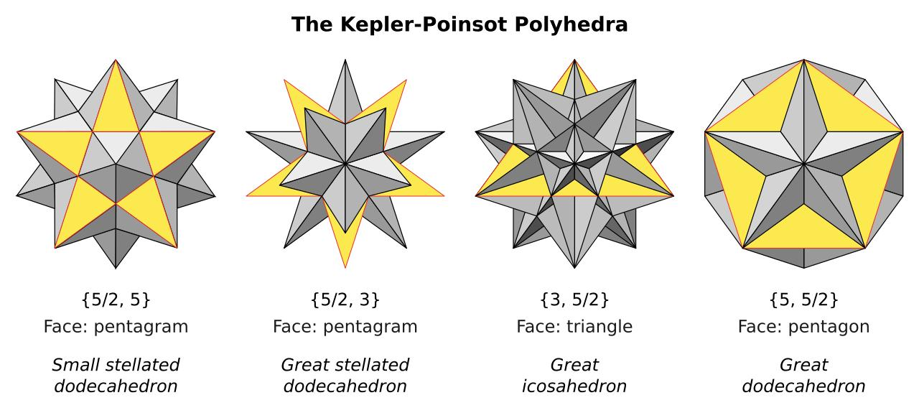
- Construct a regular dodecahedron with 12 congruent regular pentagonal faces.
- Identify the center of each pentagonal face using its diagonals.
- Extend the five sides of each pentagonal face to form a pentagram.
- Repeat this construction for all 12 pentagonal face planes.
- Identify the intersections of the extended pentagram edges.
- Arrange the extended faces so that their boundaries form the complete stellated structure.
- Check that three pentagrammic faces meet at each true vertex.
- Darken the true edges and distinguish them from internal face intersections.
- Complete the drawing by showing the visible and hidden portions of the stellated polyhedron.

Method 2: Construction by Augmenting a Regular Icosahedron
# Source: AI Source: Provided by: [Data Path: Persons Table -> ID Column: 1, Name_En Column: Motasem Essam] -> From: [ChatGPT] on [7/25/2026]
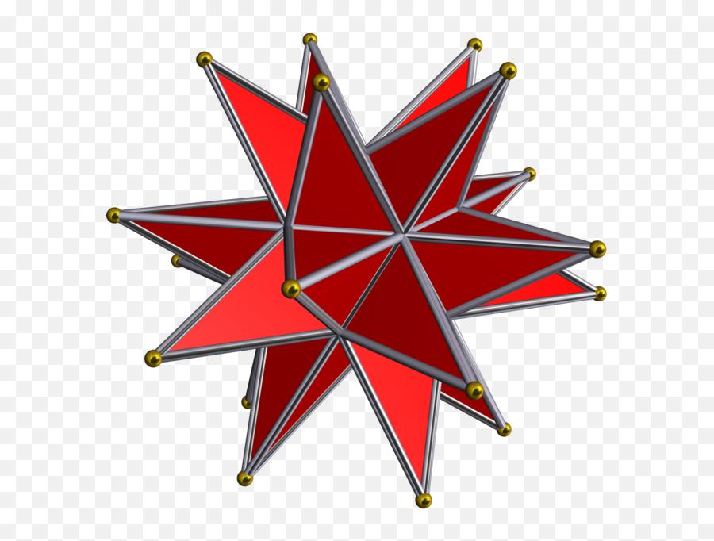
- Construct a regular icosahedron with 20 equilateral triangular faces.
- Identify the center of each triangular face.
- Draw a perpendicular construction line through each face center, extending outward.
- Determine the required height of the triangular pyramids.
- Mark one apex on each perpendicular line.
- Connect each apex to the three vertices of its triangular base.
- Repeat the procedure for all 20 triangular faces.
- Adjust the pyramid dimensions so that the triangular side faces form the required pentagrammic surface arrangement.
- Check that the resulting solid has 12 pentagrammic faces and 20 true vertices.
- Darken the visible edges and use dashed lines for hidden edges.

Method 3: Construction Using a Net and Paper Model
# Source: AI Source: Provided by: [Data Path: Persons Table -> ID Column: 1, Name_En Column: Motasem Essam] -> From: [ChatGPT] on [7/25/2026]
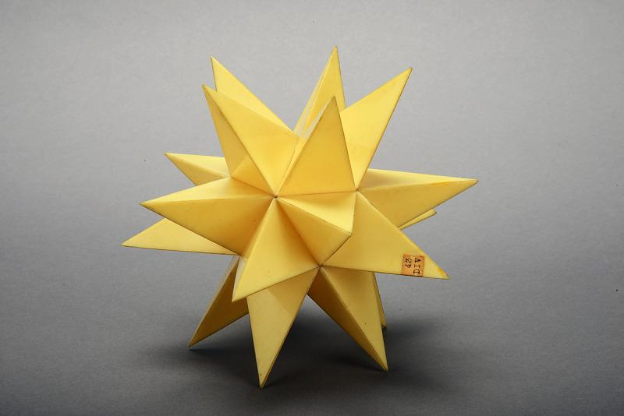
- Draw a regular icosahedron net containing 20 connected equilateral triangles.
- Construct a triangular pyramid net for each of the 20 triangular faces.
- Determine the lengths of the three lateral edges of each pyramid.
- Draw the three triangular side panels around each triangular base.
- Add attachment tabs to the pyramid panels where necessary.
- Cut out the 20 pyramid nets.
- Fold each net to form a triangular pyramid.
- Assemble the icosahedron core.
- Attach one triangular pyramid to each of its 20 faces.
- Join the components and check the alignment of the resulting pentagrammic faces.
The icosahedron augmentation method uses 20 triangular pyramids. Their dimensions must be chosen carefully to produce the great stellated dodecahedron rather than an ordinary pyramidal augmentation.

Relationship to Other Geometric Solids

Regular Dodecahedron
# Source: AI Source: Provided by: [Data Path: Persons Table -> ID Column: 1, Name_En Column: Motasem Essam] -> From: [ChatGPT] on [7/25/2026]
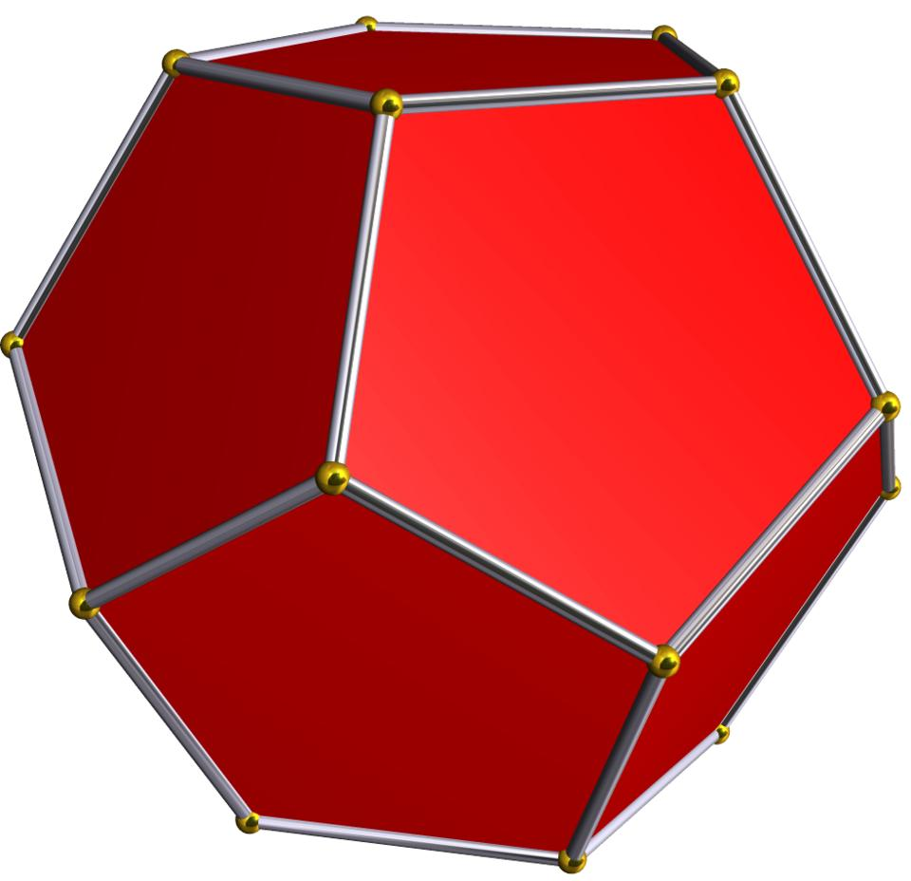
The Great Stellated Dodecahedron is a stellation of the regular dodecahedron.
- Both have 20 vertices.
- Both have 30 edges under their conventional counting.
- The regular dodecahedron has 12 convex pentagonal faces.
- The Great Stellated Dodecahedron has 12 intersecting pentagrammic faces.
The convex hull of the Great Stellated Dodecahedron is a regular dodecahedron.

Great Icosahedron
# Source: AI Source: Provided by: [Data Path: Persons Table -> ID Column: 1, Name_En Column: Motasem Essam] -> From: [ChatGPT] on [7/25/2026]
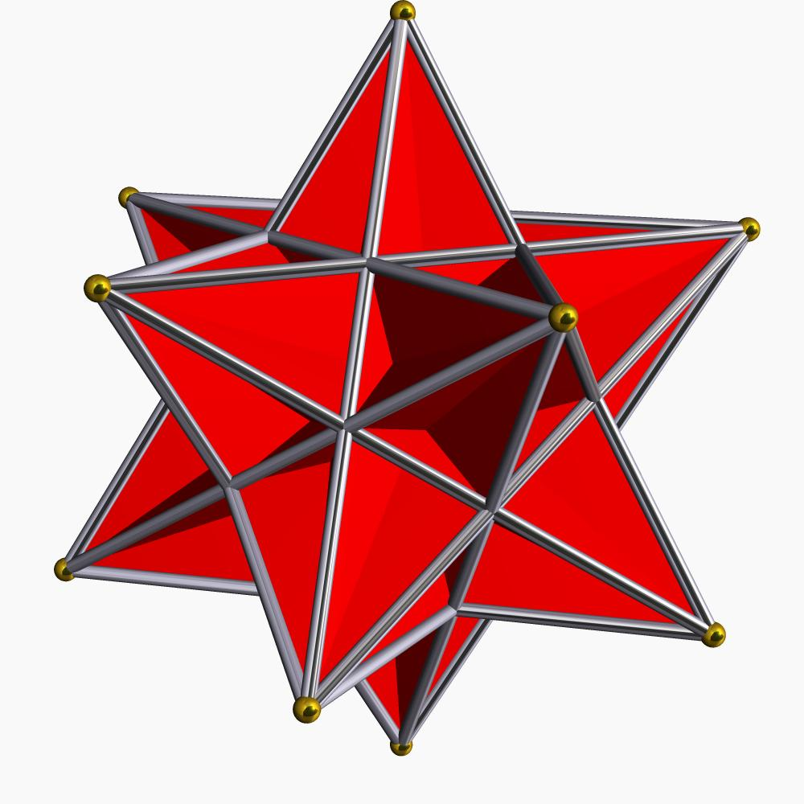
The Great Icosahedron is the dual polyhedron of the Great Stellated Dodecahedron.
Their Schläfli symbols are related by reversing their parameters:
$$\{\frac{5}{2},3\}longleftrightarrow\{3,\frac{5}{2}\}$$
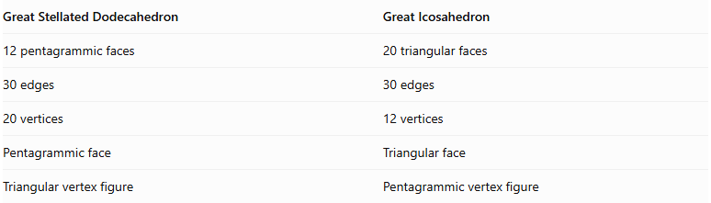
Great Stellated Dodecahedron | Great Icosahedron
12 pentagrammic faces | 20 triangular faces
30 edges | 30 edges
20 vertices | 12 vertices
Pentagrammic face | Triangular face
Triangular vertex figure | Pentagrammic vertex figure

Small Stellated Dodecahedron
# Source: AI Source: Provided by: [Data Path: Persons Table -> ID Column: 1, Name_En Column: Motasem Essam] -> From: [ChatGPT] on [7/25/2026]
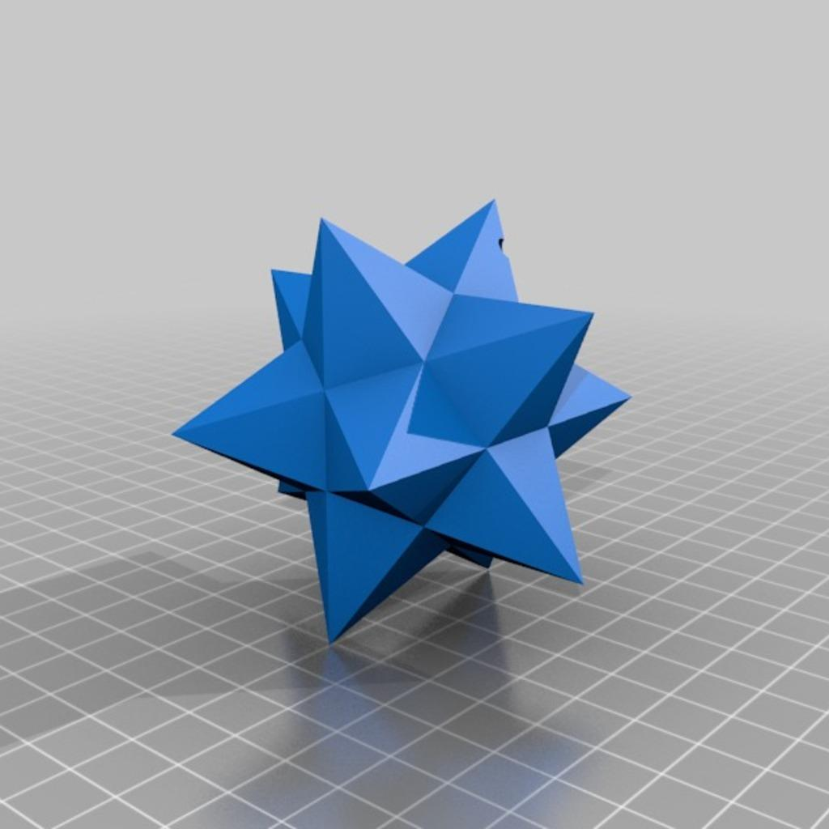
Both solids belong to the Kepler–Poinsot family and have 12 pentagrammic faces, but their vertex arrangements differ.
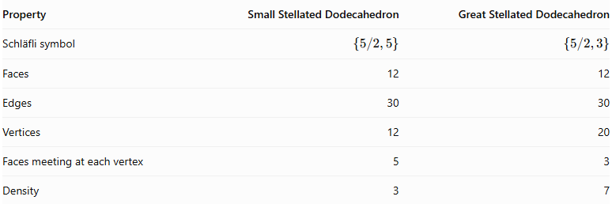
Property | Small Stellated Dodecahedron | Great Stellated Dodecahedron
Schläfli symbol | $$\{5/2,5\}$$ | $$\{5/2,3\}$$
Faces | 12 | 12
Edges | 30 | 30
Vertices | 12 | 20
Faces meeting at each vertex | 5 | 3
Density | 3 | 7

Comparison with Other Kepler–Poinsot Polyhedra
# Source: AI Source: Provided by: [Data Path: Persons Table -> ID Column: 1, Name_En Column: Motasem Essam] -> From: [ChatGPT] on [7/25/2026]
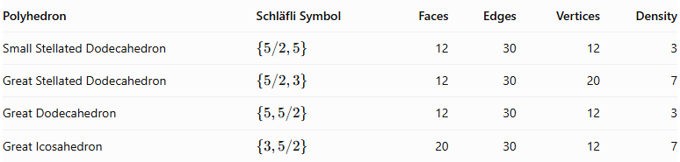
Polyhedron | Schläfli Symbol | Faces | Edges | Vertices | Density
Small Stellated Dodecahedron | $$\{5/2,5\}$$ | 12 | 30 | 12 | 3
Great Stellated Dodecahedron | $$\{5/2,3\}$$ | 12 | 30 | 20 | 7
Great Dodecahedron | $$\{5,5/2\}$$ | 12 | 30 | 12 | 3
Great Icosahedron | $$\{3,5/2\}$$ | 20 | 30 | 12 | 7

Historical Background
# Source: AI Source: Provided by: [Data Path: Persons Table -> ID Column: 1, Name_En Column: Motasem Essam] -> From: [ChatGPT] on [7/25/2026]
- Wenzel Jamnitzer (1568): Published an early representation of the Great Stellated Dodecahedron in his geometric work.
- Johannes Kepler (1619): Rediscovered and studied the solid in Harmonices Mundi.
- Louis Poinsot (1809): Independently investigated the regular star polyhedra.
- The solid became one of the four classical Kepler–Poinsot polyhedra.

Main Classification
# Source: AI Source: Provided by: [Data Path: Persons Table -> ID Column: 1, Name_En Column: Motasem Essam] -> From: [ChatGPT] on [7/25/2026]
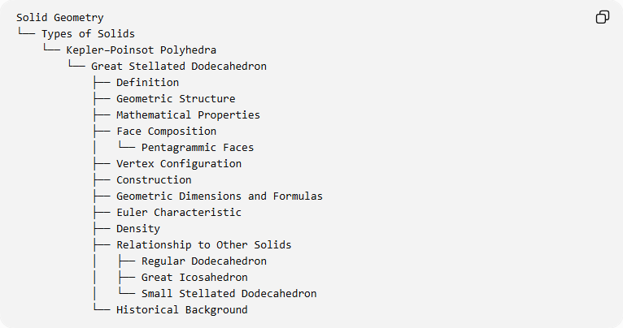
Solid Geometry
└── Types of Solids
└── Kepler–Poinsot Polyhedra
└── Great Stellated Dodecahedron
├── Definition
├── Geometric Structure
├── Mathematical Properties
├── Face Composition
│ └── Pentagrammic Faces
├── Vertex Configuration
├── Construction
├── Geometric Dimensions and Formulas
├── Euler Characteristic
├── Density
├── Relationship to Other Solids
│ ├── Regular Dodecahedron
│ ├── Great Icosahedron
│ └── Small Stellated Dodecahedron
└── Historical Background

Key Points
# Source: AI Source: Provided by: [Data Path: Persons Table -> ID Column: 1, Name_En Column: Motasem Essam] -> From: [ChatGPT] on [7/25/2026]
- The Great Stellated Dodecahedron is one of the four Kepler–Poinsot polyhedra.
- It consists of 12 regular pentagrammic faces.
- Three pentagrams meet at each of its 20 vertices.
- Its Schläfli symbol is $\{5/2,3\}$.
- It has 30 edges and 20 vertices.
- Its density is 7.
- Its dual is the Great Icosahedron.
- Its convex hull is a regular dodecahedron.
- It is a regular non-convex star polyhedron.

Conclusion
# Source: AI Source: Provided by: [Data Path: Persons Table -> ID Column: 1, Name_En Column: Motasem Essam] -> From: [ChatGPT] on [7/25/2026]
The Great Stellated Dodecahedron is a remarkable regular star polyhedron characterized by 12 intersecting pentagrammic faces, 20 vertices, and a density of 7. Its relationship with the regular dodecahedron and its dual relationship with the Great Icosahedron make it an important member of the Kepler–Poinsot family.
Further mathematical reference: Wolfram MathWorld – Great Stellated Dodecahedron.
I can continue your Kepler–Poinsot collection with the Great Icosahedron, completing the four classical regular star polyhedra.

